## **Right Triangle and Pythagoras theorem**

Pythagoras theorem: The two sides **a** and **b** of a right triangle and the hypotenuse c are related by : **a 2 + b 2 = c 2**

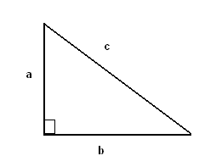

## **Area and Perimeter of Triangle**

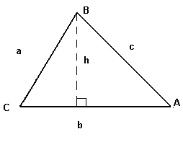

**Perimeter = a + b + c**

**Area = (1 / 2) * b * h.**

**Area = (1 / 2)* b * c sin A**

**Area = (1 / 2)* a * c sin B**

**Area = (1 / 2)* a * b sin C .**

**Heron's formula**:

Area = **sqrt [ s(s - a)(s - b)(s - c) ]** ,

where **s = (a + b + c)/2.**

## **Area and Perimeter of Rectangle**

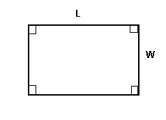

**Perimeter = 2(L + W)**

**Area = L * W**

## **Area of Parallelogram**

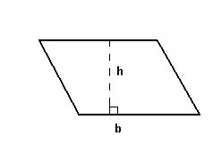

**Area = b * h**

## **Area of Trapezoid**

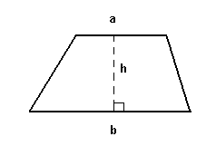

**Area = (1 / 2)*(a + b) * h**

## **Circumference of a Circle and Area of a Circular Region**

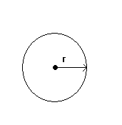

**Circumference = 2*Pi*r**

**Area = Pi*r 2**

## **Arc length and Area of a Circular Sector**

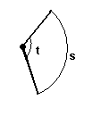

**Arc length: s = r*t**

**Area = (1/2) *r 2 * t**

where t is the central angle in **RADIANS**.

**Volume and Surface Area of a Rectangular Solid**

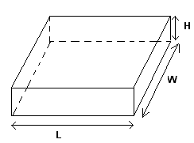

**Volume = L*W*H**

**Surface Area = 2(L*W + H*W + H*L)**

## **Volume and Surface Area of a Sphere**

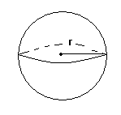

**Volume = (4/3)* Pi * r 3**

**Surface Area = 4 * Pi * r 2**

## **Volume and Surface Area of a Right Circular Cylinder**

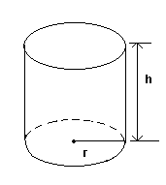

**Volume = Pi * r 2 * h**

**Surface Area = 2 * Pi * r * h**

## **Volume and Surface Area of a Right Circular Cone**

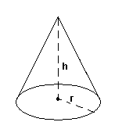

**Volume = (1/3)* Pi * r 2 * h**

**Surface Area = Pi * r * sqrt (r 2 + h 2)**